

Travis County Commissioners Court

Strategic Housing Finance Corporation
Tenant Representative
Appointment Application Packet

Application Deadline: December 4, 2026
October 27, 2026

TO: Potential Applicants

FROM: Travis County Commissioners Court

SUBJECT: Strategic Housing Finance Corporation Application Process, Timeline and Application

Attached is the Strategic Housing Finance Corporation (SHFC) Board of Directors Application Packet. Included in the packet are:
- a description of the history and mission of the SHFC;
- a summary of the qualifications the County is seeking in its appointees;
- an application form; and
- an ethics affidavit.

The deadline for receipt of completed applications is
Friday, December 4, 2026.

Applications received after the deadline will not be eligible for consideration.

Applications must be submitted electronically to: IGR@traviscountytx.gov

Electronic copies of this application packet can be found at https://www.traviscountytx.gov/igr/board-appointments

For questions or more information please contact:
IGR@traviscountytx.gov

Call for Applications to the
Strategic Housing Finance Corporation Board of Directors

The Travis County Commissioners Court seeks residents interested in working creatively in public and affordable housing. The Court is currently seeking to fill a vacancy on the Strategic Housing Finance Corporation (SHFC) for a tenant representative that is a current or former resident of an affordable housing property in which the Corporation has an ownership interest.

Applicants should be interested in working with experienced board members to shape the future of key county assets. As the community grapples with housing needs, the Court seeks to build a team of appointees to work proactively on policy, staff development and innovative business processes that will strengthen the board to provide leadership in this important arena.

The Strategic Housing Finance Corporation (SHFC) was incorporated in 2004 as a nonprofit corporation and a public instrumentality of Travis County, Texas, for the public purpose of providing financing for projects and initiatives within Travis County to maximize affordability and housing options that provide decent, safe, and sanitary housing for persons of low and moderate income. The SHFC works with private developers and public entities to research and create opportunities to create new affordable housing; the issuance of bonds and utilization of Low-Income Housing Tax Credits finance its housing acquisitions and new developments.

SKILLS DESIRED
The Travis County Commissioners Court is seeking qualified applicants who will participate actively in the work of the Board and dedicate their time, talent, and energy to the mission of the SHFC. Examples of desired skills include, but are not limited to one or more of the following:
• finance and accounting principles
• familiarity with federal and state housing funding sources
• knowledge of financing tools such as bonds, tax credits & incentives
• development/construction/property management
• experience working with diverse & special needs populations
• social services/nonprofit organizations
• strategic planning, and
• affordable/public housing.

STRATEGIC HOUSING FINANCE CORPORATION BOARD OF DIRECTORS

APPLICANT CONTACT SHEET

Applicant Contact Information
Name:
Spouse’s Name:
Home Telephone # | Cellular # (Optional)
Email Address
Residential Home Address (Required to confirm appointment eligibility)

Applicant Demographic Information
Date of Birth: | County Commissioner Precinct:
Gender (Optional): | Preferred Pronouns (Optional):
Race/Ethnicity (Optional):
Prefer Not to Indicate

How did you learn about this vacancy?
County website | Facebook/Twitter | Email from IGR
Friend/Associate | News Story | Next Door

Other:

SHFC Tenant Status
Current Tenant | Former Tenant

Name & Address of Development:
Dates Lived at Development:

STRATEGIC HOUSING FINANCE CORPORATION

BOARD OF DIRECTORS APPLICATION
Applicant Name

Statement of Purpose

In 150 words or less briefly summarize why you are seeking this appointment.

Education/Training History
High School or equivalent (G.E.D.)
Undergraduate School:
Degree:
Graduate School:
Degree:
Licenses/Certifications:

Current Employment Information
Name
Work #
Email
Address

Most Recent Past Employment
Employer
Job Title
Other Highlights

Other Relevant Work, Public Service, or Civic Participation Experience

Please Share Any Other Relevant Information Not Covered in This Application

STRATEGIC HOUSING FINANCE CORPORATION BOARD OF DIRECTORS

Certification of Applicant

I hereby certify that the foregoing and any attached statements are true, accurate and complete. I agree that any misstatement, misrepresentation, or omission of a fact may result in my disqualification for appointment. I assign and hereby give Travis County full authority to conduct background investigations pertinent to this application.

I agree to file the following affidavit of eligibility prior to being considered for an appointment by Travis County. I further agree to file an amendment in the event my status should change during the tenure of my appointment.

Further, I understand that the information provided in this application will be considered a government record and is subject to the disclosure and exception provisions of the Texas Public Information Act and all other statutory requirements.

Lastly, I understand that interviews will be conducted in a public forum in accordance with the requirements of the Texas Open Meetings Act and any other statutory requirements or exceptions.

Printed Name | Applicant’s Signature
Date

More information about the Texas Open Meetings Act and the Texas Public Information Act can be found by visiting https://www.texasattorneygeneral.gov.

STRATEGIC HOUSING FINANCE CORPORATION BOARD OF DIRECTORS

Affidavit of Eligibility for Appointment

I, _______________________________________, declare or affirm that I am capable of making this affidavit and that the information contained in this government record/document is true and correct. I am making this affidavit to establish that I meet all eligibility requirements established by the Travis County Commissioners Court for appointment to the Strategic Housing Finance Corporation and submit the information under the penalty of perjury, on _____________________, 2026.

Accordingly, I hereby affirm that all of the following statements are true:

- I am a resident of Travis County.

- Neither I, nor my spouse or minor children, own 10 percent or more of the voting stock of a corporation, partnership, or other business association that transacts business with the Strategic Housing Finance Corporation.

- Neither I, nor my spouse or minor children, owns either 10 percent or $15,000 or more of the fair market value of a corporation, partnership, or other business association that transacts business with the Strategic Housing Finance Corporation.

- Neither I, nor my spouse or minor children, received more than 10 percent of our gross personal income last year from a corporation, partnership, or other business association that transacts business with the Strategic Housing Finance Corporation.

- I have not been or am not barred, suspended, or terminated from procurement in a state or Federal program or listed in the U.S. Department of Housing and Urban Development’s System for Award Management (SAM).

- I have not been convicted of a state or federal felony crime involving fraud, bribery, theft, misrepresentation of material fact, misappropriation of funds, or other similar criminal offenses.

- I am not subject to an enforcement or disciplinary action under state or federal securities law or by the NASD; am not subject to a federal tax lien; and am not the subject of a proceeding in which a Governmental Entity has issued an order to impose penalties, suspend funding, or take adverse action based on an allegation of financial misconduct or uncured violation of material laws, rules, or other legal requirements governing activities considered relevant by the Governmental Entity.

- I have not breached a contract with a public agency and failed to cure that breach within the time frame provided or allowed by contract.

- I have not been found by the Board of Texas Department of Housing and Community Affairs (the “Department”) to be ineligible based on a previous participation review performed in accordance with 10 TAC Chapter 1 Subchapter C.

- I am not delinquent in any loan, fee, or escrow payments to the Department in accordance with the terms of the loan, as amended, and am otherwise not in default with any provisions of such loans.

- I am not subject to a state revolving door or other standard of conduct or conflict of interest statute, including §2306.6733 of the Texas Government Code, or a provision of Chapter 572 of the Texas Government Code, that might involve the Department.

- I am not or have not been a member of the TDHCA Board or employed by the Department as the Executive Director, Deputy Director, Director of Housing Programs, Director (Chief) of compliance, Director of underwriting, or low income housing tax credit program manager, a manager over the program for which an Application has been submitted, or any person exercising such responsibilities regardless of job title that is in violation of §2306.6733 of the Texas Government Code.

- I am not subject to any pending criminal proceedings.

- I am a current or former tenant of an affordable housing property in which the Strategic Housing Finance Corporation has or had an ownership interest.

___________________________________
Signature

STRATEGIC HOUSING FINANCE CORPORATION BOARD OF DIRECTORS

Application Checklist

Thank you for your interest in applying. To ensure that your application is ready for submission, please make sure that you have done the following:

- Completed all relevant fields on the Applicant Contact Sheet and Application. A home address MUST be provided to verify residency.
- Signed the Certification of Applicant Form
- Signed the Affidavit of Eligibility

Applications will not be considered for eligibility unless they are complete, submitted by the application deadline, and submitted to IGR@traviscountytx.gov. We cannot guarantee that applications sent to any other email address will be received by IGR.

If you have any questions about the application or need assistance, please email IGR@traviscountytx.gov.

Interview Process Information

Your application may be all, or in part, subject to release under the Texas Open Meetings Act and the Texas Public Information Act and/or be publicly posted as part of backup documentation for Commissioner Court meetings. More information about these provisions can be found by visiting https://www.texasattorneygeneral.gov. Please notify igr@traviscountytx.gov if your information is subject to shielding provisions as allowed by law.

You will be notified of your selection for an interview at least one week before the interview date. Please make yourself available that day. If you are not available, please note this in the portion of the application that asks for your availability.

Intergovernmental Relations will send you a list of interview times and will ask for you to rank them in order of preference. Interview times will be granted in the order they are received but IGR will make a best effort to accommodate specific schedule limitations.

Your interview will be held in front of the five-member Commissioners Court at 700 Lavaca. The interviews will be conducted in open court, although they may be held in Executive Session at the Court’s discretion. Court sessions are recorded and televised in real-time.

Interview questions will not be shared ahead of time but we encourage all applicants to familiarize yourself with the functions and duties of the Board/Commission you are applying for.

Out of respect to other candidates, we will ask that you wait outside the Commissioners Courtroom until your interview time. Intergovernmental Relations staff will escort you once it is your turn and escort you out once the interview is over.

Parking is available for free in the 700 Lavaca Parking Garage, located at 886 Guadalupe Street.

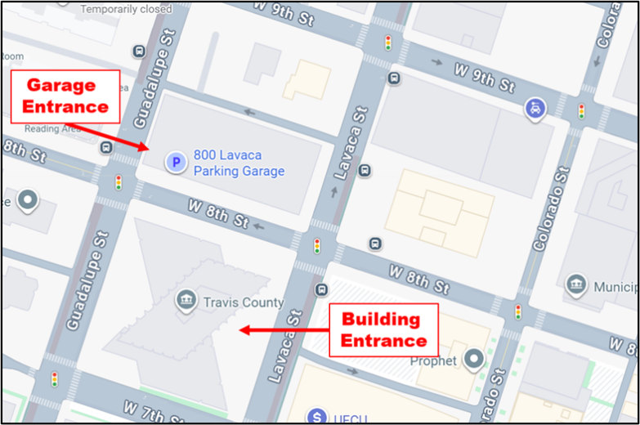

From the parking garage, you will take the elevator to Level 1, which is the street level. The entrance is on the Lavaca side of the building. Please go to the security desk and let the officer on duty know you are being interviewed by the Commissioners Court. They will direct you to the Hall of Government, located behind their desk. Please wait in this lobby area. IGR staff will meet you and give you further instructions upon your arrival.

