

Travis County Commissioners Court

Strategic Housing Finance Corporation
Board of Directors
Appointment Application Packet

Application Deadline: May 29, 2026

Call for Applications to the
Strategic Housing Finance Corporation Board of Directors

Date Issued: Tuesday, April 28, 2026
Application Deadline: Friday, May 29, 2026

The following pages include the Application Packet for appointment to the Strategic Housing Finance Corporation Board of Directors Application Packet. Included in the packet are a description of the history and mission of the Strategic Housing Finance Corporation; a summary of the qualifications the County is seeking in its appointees; and an application form.

HOW TO APPLY
Please submit the completed Application Packet electronically to: IGR@traviscountytx.gov.

Applications must be received by Friday, May 29, 2026. Applications received after the deadline will not be eligible for consideration.

For questions regarding the application or process please contact IGR@traviscountytx.gov.

General information about board appointments can be found by visiting: https://www.traviscountytx.gov/igr/board-appointments

Information about the Strategic Housing Finance Corporation can be found by visiting: https://shfctx.com

Call for Applications to the
Strategic Housing Finance Corporation Board of Directors
History, Mission, and Qualifications

The Travis County Commissioners Court seeks residents interested in working creatively in public and affordable housing. The Court is looking to fill one vacancy on the Strategic Housing Finance Corporation (SHFC).
Applicants should be interested in working with experienced board members to shape the future of key county assets. As the community grapples with housing needs, the Court seeks to build a team of appointees to work proactively on policy, staff development and innovative business processes that will strengthen the organization to provide leadership in this important arena. County staff is engaged with the board to assist in developing a roadmap that will assist new and current members in planning for action.
STRATEGIC HOUSING FINANCE CORPORATION
The Strategic Housing Finance Corporation (SHFC) was incorporated in 2004 as a nonprofit corporation and a public instrumentality of Travis County, Texas, for the public purpose of providing financing for projects and initiatives within Travis County to maximize affordability and housing options that provide decent, safe, and sanitary housing for persons of low and moderate income. The SHFC works with private developers and public entities to research and create opportunities to create new affordable housing; the issuance of bonds and utilization of Low-Income Housing Tax Credits finance its housing acquisitions and new developments.
QUALIFICATIONS
The Travis County Commissioners Court is seeking qualified applicants who will participate actively in the work of the Board and dedicate their time, talent, and energy to the mission of the SHFC. In particular, the Court is looking for applicants familiar with one or more of the following:
- finance and accounting principles
- familiarity with federal and state housing funding sources
- knowledge of financing tools such as bonds, tax credits & incentives
- development and construction processes
- property management
- experience working with diverse & special needs populations
- social services/nonprofit organizations
- strategic planning, and
- affordable/public housing.

You can find more information about the Strategic Housing Finance Corporation by visiting: https://shfctx.com
Current or former residents of a public housing unit are encouraged to apply, although that is not a required qualification for appointment.

Applicants must be a current resident of Travis County.

STRATEGIC HOUSING FINANCE CORPORATION BOARD OF DIRECTORS
Applicant Contact Sheet
Applicant Contact Information
Name
Spouse’s Name
Mobile / Home Phone Number
Email Address
Residential Home Address (Required to verify residency)

County Commissioner Precinct | Pct. 1 | Pct. 2 | Pct. 3 | Pct. 4

Applicant Information
Date of Birth |  | Preferred Pronouns
Female | Male |  | Prefer Not to Indicate
How did you learn about this vacancy?

Race/Ethnicity
Prefer not to indicate

Housing Status

I have experienced homelessness: (Please select all that apply.)
Currently | In the past | Never

I have lived in a public housing unit: (Please select all that apply.)
Currently | In the past | Never
If you are a current/former tenant, please complete the below information.

Name of Development:
Years Lived at Development:
City/State where the Development is located if outside Travis County:

STRATEGIC HOUSING FINANCE CORPORATION BOARD OF DIRECTORS

Appointment Application
Applicant Name

 | Statement of Purpose
 | In 150 words or less briefly summarize why you are seeking this appointment.
Skills
Administration & Operations  Board Development  Community Networking  Counseling  Education  Event Planning |  | Facilities Management  Financial Management  Fundraising/Grant Writing  Health Care  Program Development  Program Evaluation | Public Relations  Staffing/HR  Strategic Planning  Training  Volunteer Management  Writing/Communication

Please highlight any other relevant skills and experience you would bring to the board.

Education History
High School or equivalent (G.E.D.):
Trade School/Vocational Program:
Focus and Years Attended:
Community College:
Degree and Years Attended:
Undergraduate School:
Degree and Years Attended:
Graduate School:
Degree and Years Attended:

Current Employment Information
Employer
Job Title
Email/Work #
Start and End Dates
Most Recent Past Employment
Employer
Job Title
Email/Work #
Start and End Dates
Community Participation: Public Service, Civic Engagement, Volunteer Experience

Community-Based Housing Experience and/or Knowledge:
Additional Information:
Please include any other relevant information that was not included in this application that you would like to share.

Please attach a separate, detailed resume.

STRATEGIC HOUSING FINANCE CORPORATION BOARD OF DIRECTORS

Certification of Applicant

I hereby certify that the foregoing and any attached statements are true, accurate and complete. I agree that any misstatement, misrepresentation, or omission of a fact may result in my disqualification for appointment. I assign and hereby give Travis County full authority to conduct background investigations pertinent to this application.

I agree to file the following affidavit of eligibility prior to being considered for an appointment by Travis County. I further agree to file an amendment in the event my status should change during the tenure of my appointment.

Further, I understand that the information provided in this application will be considered a government record and is subject to the disclosure and exception provisions of the Texas Public Information Act and all other statutory requirements.

Lastly, I understand that interviews will be conducted in a public forum in accordance with the requirements of the Texas Open Meetings Act and any other statutory requirements or exceptions.

Printed Name | Applicant’s Signature
Date

More information about the Texas Open Meetings Act and the Texas Public Information Act can be found by visiting https://www.texasattorneygeneral.gov.

STRATEGIC HOUSING FINANCE CORPORATION BOARD OF DIRECTORS

Affidavit of Eligibility for Appointment

I, _______________________________________, declare or affirm that I am capable of making this affidavit and that the information contained in this government record/document is true and correct. I am making this affidavit to establish that I meet all eligibility requirements established by the Travis County Commissioners Court for appointment to the Strategic Housing Finance Corporation and submit the information under the penalty of perjury, on _____________________, 2026.

Accordingly, I hereby affirm that all of the following statements are true:

- I am a resident of Travis County.

- Neither I, nor my spouse or minor children, own 10 percent or more of the voting stock of a corporation, partnership, or other business association that transacts business with the Strategic Housing Finance Corporation.

- Neither I, nor my spouse or minor children, owns either 10 percent or $15,000 or more of the fair market value of a corporation, partnership, or other business association that transacts business with the Strategic Housing Finance Corporation.

- Neither I, nor my spouse or minor children, received more than 10 percent of our gross personal income last year from a corporation, partnership, or other business association that transacts business with the Strategic Housing Finance Corporation.

- I have not been or am not barred, suspended, or terminated from procurement in a state or Federal program or listed in the U.S. Department of Housing and Urban Development’s System for Award Management (SAM).

- I have not been convicted of a state or federal felony crime involving fraud, bribery, theft, misrepresentation of material fact, misappropriation of funds, or other similar criminal offenses.

- I am not subject to an enforcement or disciplinary action under state or federal securities law or by the NASD; am not subject to a federal tax lien; and am not the subject of a proceeding in which a Governmental Entity has issued an order to impose penalties, suspend funding, or take adverse action based on an allegation of financial misconduct or uncured violation of material laws, rules, or other legal requirements governing activities considered relevant by the Governmental Entity.

- I have not breached a contract with a public agency and failed to cure that breach within the time frame provided or allowed by contract.

- I have not been found by the Board of Texas Department of Housing and Community Affairs (the “Department”) to be ineligible based on a previous participation review performed in accordance with 10 TAC Chapter 1 Subchapter C.

- I am not delinquent in any loan, fee, or escrow payments to the Department in accordance with the terms of the loan, as amended, and am otherwise not in default with any provisions of such loans.

- I am not subject to a state revolving door or other standard of conduct or conflict of interest statute, including §2306.6733 of the Texas Government Code, or a provision of Chapter 572 of the Texas Government Code, that might involve the Department.

- I am not or have not been a member of the TDHCA Board or employed by the Department as the Executive Director, Deputy Director, Director of Housing Programs, Director (Chief) of compliance, Director of underwriting, or low income housing tax credit program manager, a manager over the program for which an Application has been submitted, or any person exercising such responsibilities regardless of job title that is in violation of §2306.6733 of the Texas Government Code.

- I am not subject to any pending criminal proceedings.

___________________________________
Signature

STRATEGIC HOUSING FINANCE CORPORATION BOARD OF DIRECTORS

Application Checklist

Thank you for your interest in applying. To ensure that your application is ready for submission, please make sure that you have done the following:

- Completed all relevant fields on the Applicant Contact Sheet and Application. A home address MUST be provided to verify residency.
- Attached a resume
- Signed the Certification of Applicant Form
- Signed the Affidavit of Eligibility

Applications will not be considered for eligibility unless they are complete, submitted by the application deadline, and submitted to IGR@traviscountytx.gov. We cannot guarantee that applications sent to any other email address will be received by IGR.

If you have any questions about the application or need assistance, please email IGR@traviscountytx.gov.

Interview Process Information

Your application may be all, or in part, subject to release under the Texas Open Meetings Act and the Texas Public Information Act and/or be publicly posted as part of backup documentation for Commissioner Court meetings. More information about these provisions can be found by visiting https://www.texasattorneygeneral.gov. Please notify igr@traviscountytx.gov if your information is subject to shielding provisions as allowed by law.

You will be notified of your selection for an interview one week before the interview date. Currently, interviews are expected to be held on Tuesday, June 23rd. Please make yourself available that day. If you are not available, please note this in the portion of the application that asks for your availability.

Intergovernmental Relations will send you a list of interview times and will ask for you to rank them in order of preference. Interview times will be granted in the order they are received but will make a best effort to accommodate specific schedule limitations.

Your interview will be held in front of the five-member Commissioners Court at 700 Lavaca. The interviews will be conducted in open court, although they may be held in Executive Session at the Court’s discretion. Court sessions are recorded and televised in real-time.

Interview questions will not be shared ahead of time but we encourage all applicants to familiarize yourself with the functions and duties of the constable’s office.

Out of respect to other candidates, we will ask that you wait outside the Commissioners Courtroom until your interview time. Intergovernmental Relations staff will escort you once it is your turn and escort you out once the interview is over.

Parking is available for free in the 700 Lavaca Parking Garage, located at 886 Guadalupe Street.
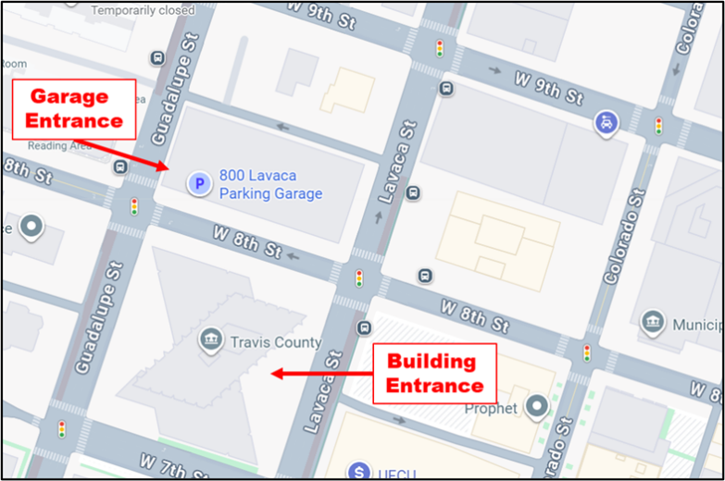
From the parking garage, you will take the elevator to Level 1, which is the street level. The entrance is on the Lavaca side of the building. Please go to the security desk and let the officer on duty know you are being interviewed by the Commissioners Court. They will direct you to the Hall of Government, located behind their desk. Please wait in this lobby area. IGR staff will meet you and give you further instructions upon your arrival.

